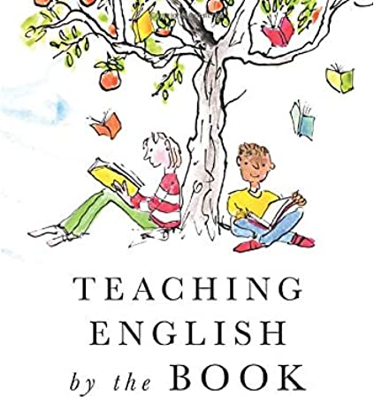
Book title: Tales of a Fourth Grade Nothing
Worksheet 1-Chapter 1
Name: …………………………………………………………………
Date: …………………………………………………………………

- Reading Comprehension
Read Chapter 1 and answer the following questions.

- Peter wins Dribble in a football match. | T | F
- Dribble is a pet turtle. | T | F
- Peter’s apartment isn’t on the 11th floor. | T | F
- Peter’s mum is happy with the new pet. | T | F
- Peter’s dad usually watches TV. | T | F
- Peter’s biggest problem is Juicy-O. | T | F
- Fudge likes Dribble. | T | F
- Connecting to Language-Grammar
Time to revise plurals!

Singular | Plural | Singular | Plural
Child |  | Mouse
Suitcase |  | Family
Tooth |  | City
Party |  | Foot
Country |  | Sheep
- Fun-Creativity
Choose one sentence from Chapter 1. Write it in the box and draw a relevant picture.

Sentence:

