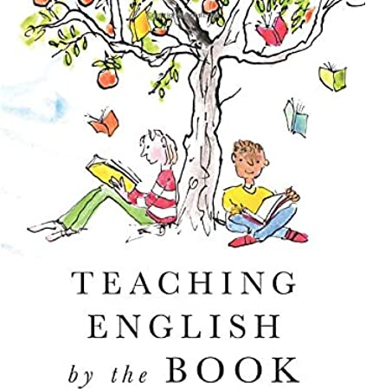
Book title: Tales of a Fourth Grade Nothing
Worksheet 2-Chapter 2
Name: …………………………………………………………………
Date: …………………………………………………………………

- Reading Comprehension
Read Chapter 1 and complete the summary with the words below:
hotel, noisy, train, Chicago, book, talks, juice, flowers

Peter’s father invites Mr. and Mrs. Yarby to stay with them for the weekend. They live in …………………………… but they are visiting New York. Peter’s mother doesn’t agree and wants them to stay in a ……………………… Peter will have to sleep with Fudge for two days and this is a problem because Fudge…………………………… in his sleep. While mum is making preparations, Fudge eats some ……………………………! Mr. and Mrs. Yarby bring some presents for the boys: a ……………………… for Fudge and a ……………………………… for Peter. They enjoy the dinner and they drink their favorite ………………………………! They all sleep but the boys are very ………………………………… so Mr. and Mrs. Yarby decide to leave the next day!

- Connecting to Language-Vocabulary
Find words about the house in Chapter 2.
House
b _ _ _ _ _ m  b _ _ _ _ _ t  s _ _ a  l _ _ _ _ g r _ _ m | c _ _ _ r  k _ _ _ _ _ n  d _ _ _ _ g r _ _ m

Can you find 5 fruit in this chapter?
- ………………………………………………………………………
- ………………………………………………………………………
- ………………………………………………………………………
- ………………………………………………………………………
- ………………………………………………………………………

- Speaking
What is the best present you have received?
What present do you want to get from Santa this year?

