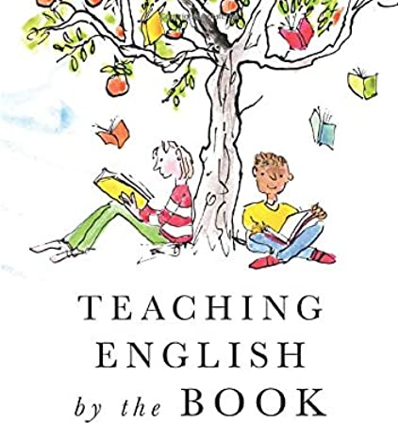
Book title: Tales of a Fourth Grade Nothing
Worksheet 3-Chapter 3
Name: …………………………………………………………………
Date: …………………………………………………………………

- Reading Comprehension
Read Chapter 3 and answer the questions.

- What does Fudge stop doing?
- What does Peter do to make Fudge eat?
- Who is the family dog?
- What does Grandma make for Fudge?
- Who solves the problem in the end?

- Connecting to Language-Present Continuous
Complete the sentences using the Present Continuous of the verbs in brackets.

- Peter ……………………………………………………… (stand) on his head and he ………………………………… (teach) Fudge how to do it.
- Dad ……………………………………………… (do) tricks while Mum …………………………………… (feed) Fudge.
- Fudge ……………………………………………… (play) with boxes of cereals in the kitchen and he ……………………………………………… (sit) under the table.
- Grandma ……………………………………………… (visit) them and they ………………………………………… (cook) together.
- The doctors ………………………………………………… (examine) Fudge.

- Bingo!

